Yum: Starting the Conversation
By: Tacicia Bryan
December 6th was a huge milestone for the York University Market (YUM); it marks the end of their first season in operation. YUM is a weekly Farmers’ Market located on the first floor of the TEL Building at York University. It operates every Thursday during the regular school semester from 12pm to 4pm. With the help of about twenty vendors, YUM lives up to its name: from vegan pizzas, fresh produce, gluten-free pastries to pretzels and beef jerky, you can find something to tantalize your taste buds. For those searching for cool souvenirs, there are options for you as well. This event showcased some amazing student projects and arts and crafts.
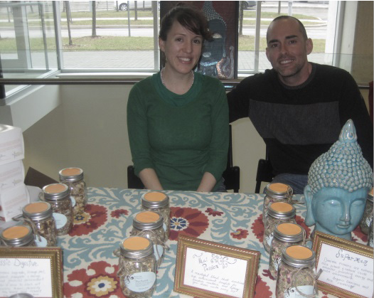
(Pictured above, two vendors offering herbs and spices)
The York University Market is a project of Regenesis, a student-run organization specializing in environmental sustainability and social justice. The idea of a weekly Farmer’s Market came from a 2010 Harvestfest where local vendors were introduced to the student population at York. Upon seeing the success of that event, Regenesis executives petitioned for a weekly Farmers’ Market for the student body.
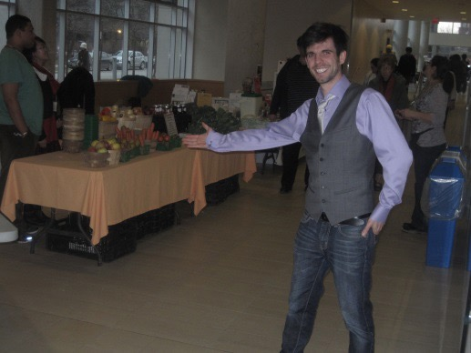
After almost three years of negotiations, the York University Market finally launched in September 2013. In an interview with the Communication Studies Students’ Association (CSSA), Chris Bentley, the man behind the scenes, discussed YUM’s impact on York University’s food system. Originally from Manitoba, Chris is currently a Master’s Degree student at York. Although he was not part of the original push to introduce the Farmer’s Market, his efforts have helped to transform YUM into a successful endeavour. He works closely with Regenesis to make their vision for the York University Market possible. “We want to transform what food sustainability looks like economically, socially and nutritionally.” Chris explains, “Food is fundamental: it’s an experience, something everyone loves. We derive so much meaning from food. This is not about making a political stance; we want a productive space for ideas to be exchanged.”
While speaking with Chris, one word continued to come up: ‘conversation.’ The idea behind the market was to introduce a learning space for people to discuss food amongst themselves and with local entrepreneurs. Engaging with vendors also allows for some demystification of food production, further enabling discourse. Here, students can explore the ecological, economic, cultural and health implications of community markets. This could potentially change the way people view food sustainability. Chris hopes to complement the market with his academic research and theories of socio-ecological learning in adult commons.
This concept might sound very familiar to communication majors, especially if they’ve taken courses in political economy. YUM’s open space for learning and exchange is a contemporary example of Habermas’ public sphere. The ideal public sphere is traditionally described as a space where ideas can be exchanged, free from commercial, private, market and state influences. Traditional spaces have included religious institutions, coffee houses, public squares and other open spaces. Regenesis hopes to build from this model at the weekly market.
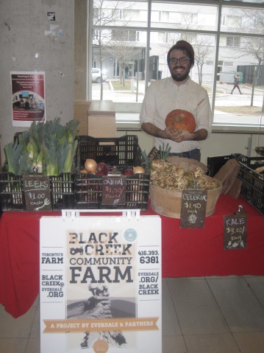
(Vendor from Black Creek Community Farm, pictured above)

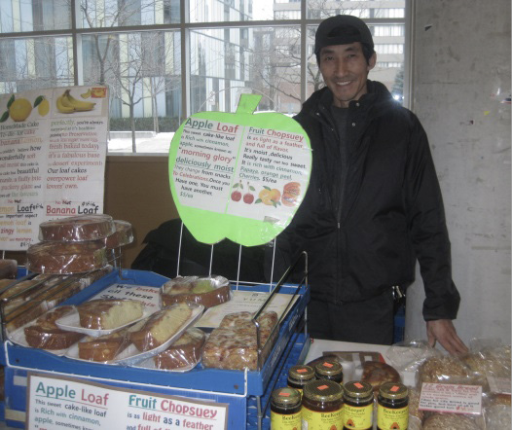
While members acknowledge that this is not a perfect public sphere, as it includes market interests, it is a starting point that could lead to many possibilities. While they welcome support from corporate bodies, they also explore alternative ways to begin the conversation amongst the York population. For example, Aramark is a major food distributor for York cafeterias; it provides YUM with some food cooked by its chefs. Regenesis offers a space for independent vendors, as well as a free store at the same market. People attending the Farmers Market can discuss so much from that contrast alone. Different political and social contexts have come together to shape and influence the success or viability of YUM. In doing so, they have created a space where many people can come and participate in the market space.

(Vendor selling apple-based products and baked goods)
One question that generated interest was the direction of the York University Market. Would there be more ethnic food options? Is a permanent food market feasible - more available days or fixed location, perhaps? How did they want to continue and expand this endeavour? When asked about these issues, the Regenesis team offered interesting responses. While they wished to explore opportunities for growth that opened more food ways, Regenesis representatives state that they wish for the market experience to highlight the university itself. Chris explains, “We’re not trying to represent anyone except York.” As they continue to grow and expand, hopefully they’ll have more diverse options.
One of the co-presidents of Regenesis, Darnel Harris, explains the vision for the York University Market. One goal is to have a permanent space on campus, with the possibility of a daily exchange. Through this, they would like to continue to host a forum discussing food sustainability and the future of food production. As to a fixed location at York University, Regenesis is setting its sights on York University’s construction plans for 2016.
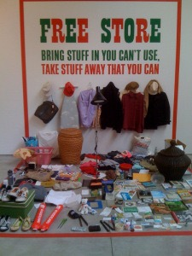
Darnel explains that with the introduction of two new subway stations, York intends to transform itself into a “Campus in the City.” The one thing a city would always need is a food market of some sort. He hopes to gain the support of the student body through the survey currently being offered through Lands for Learning, a project centre in York Lanes. The urban planning team is focused on York University’s urban planning. Currently, the team is encouraging student participation. If you would like to include your own input, visit the Lands for Learning office located across from the bookstore in York Lanes or see their website: http://www.yudc.ca/landsfor- learning/GetInvolved.html.
While a permanent space and daily market exchanges are a positive change for York’s student body, sustainability would ironically be a factor here. Both Chris and Darnel acknowledge that a daily food forum may pose difficulties for vendors. Input is also needed to continue the Free Store (pictured above, left), a clothing exchange based on gift economy. As Regenesis officials continue to discuss ideas and plan strategies, they hope to find ways to assuage the precariousness of food production and sales for local vendors and donors.
Overall, the York University Market shows a lot of promise. There may be things to analyse and explore in the future, but in the beginning stages, YUM is doing a remarkable job. Right now, the greatest issue facing them is creating awareness within the student body. Addressing students and faculty and garnering support for their cause is an effective way to ensure a space for the Farmers Market in the future. It will be interesting to see the market develop to its fullest potential.
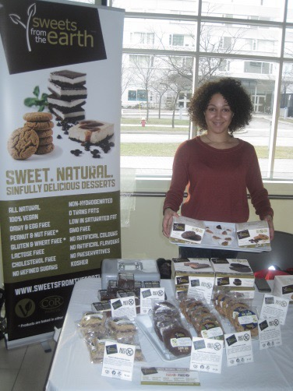
York University students provided a wide array of options. There was a jewellery display, a table showcasing holiday decorations as well as a promotion for printing services. At another student table, the vendor sold up-cycled jewellery that she had fashioned from silverware. Visiting the market offers a great opportunity to learn about different food ways and about food sustainability. You can also join the conversation! If you are a creative individual interested in participating in the Farmers Market, YUM is always looking for independent student vendors.
If art and cuisine are not your forte, there are other ways to support our Farmers Market and participate in the sustainability discussion. The York University Market is looking for volunteers to help on Thursdays. You can sign up for a two-hour shift between 10am and 4pm. You can also donate to the free store offered at YUM: drop off any unwanted items in a box at the Regenesis reception area 353B from 8:30am to 5pm. The Regenesis donation centre is located on the third door of York Lanes.
If you are interested in participating in the York University Market as a volunteer or a local entrepreneur, giving constructive feedback or wish to find out more information, feel free to contact Chris Bentley at farmersmarket.yorku@gmail.com. For more information about Regenesis, visit their website: http// regenesisyork.wordpress.com/.

